**INDIA’S AGRICULTURE CROP PRODUCTION**

**TEAM NO : 4**

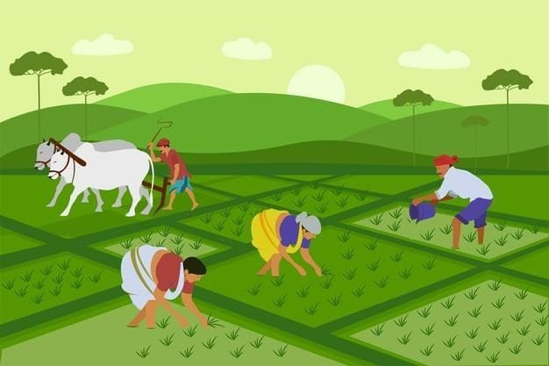

SRINIVASAN R

TEAM NO : 4

GOVERNMENT ARTS COLLEGE FOR MEN, NANDANAM

**1 INTRODUCTION**

India is the second largest producer of wheat and rice, the world's major food staples. India is currently the world's second largest producer of several dry fruits, agriculture-based textile raw materials, roots and tuber crops, pulses, farmed fish, eggs, coconut, sugarcane and numerous vegetables. In this project explain the above in the content..

1.1 OVER VIEW

My team’s this project explains that agricultural crop production of each states are present in India.

1.2 PURPOSE

India's food security depends on producing cereal crops, as well as increasing its production of fruits, vegetables and milk to meet the demands of a growing population with rising incomes. this project helps to needy farmers.

**2 PROBLEM DEFINITION & DESIGN THINKING**

2.2 EMPATHY MAP

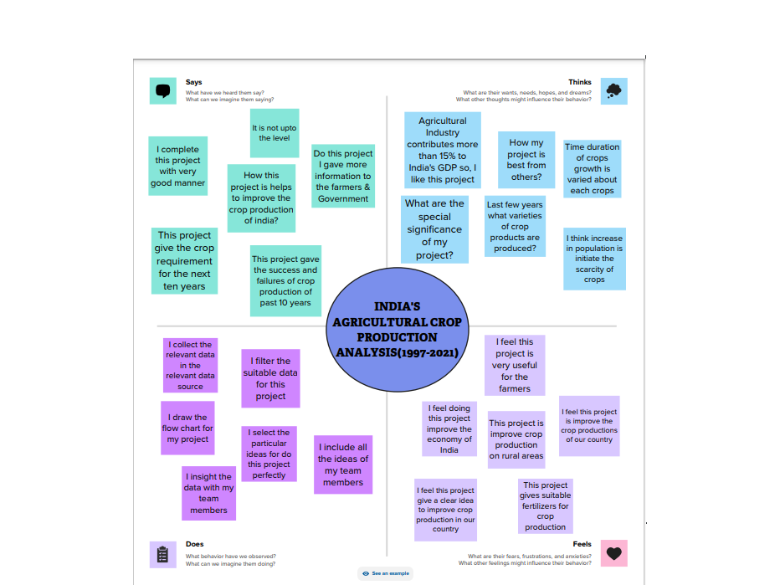

2.2 IDEATIONN & BRAINSTORMING MAP

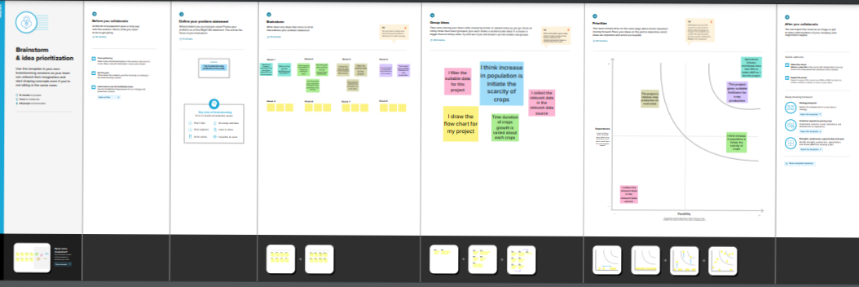

**3 RESULT**

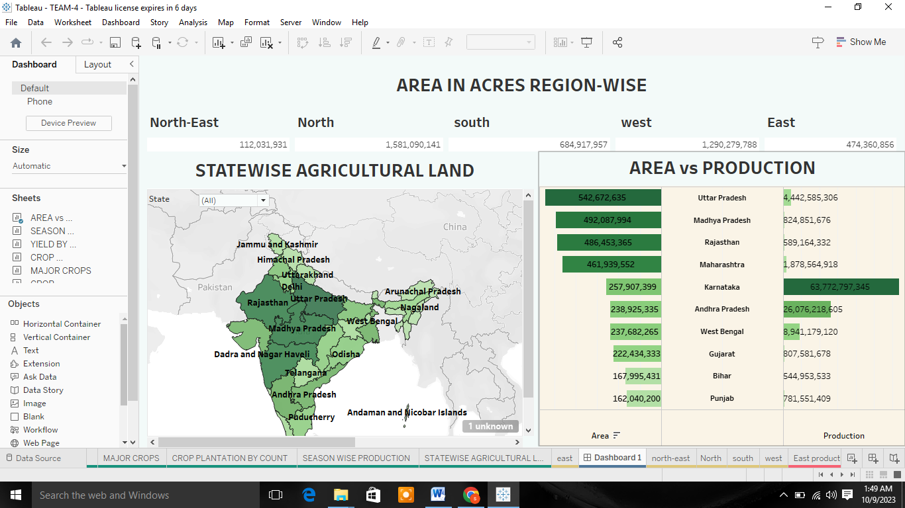

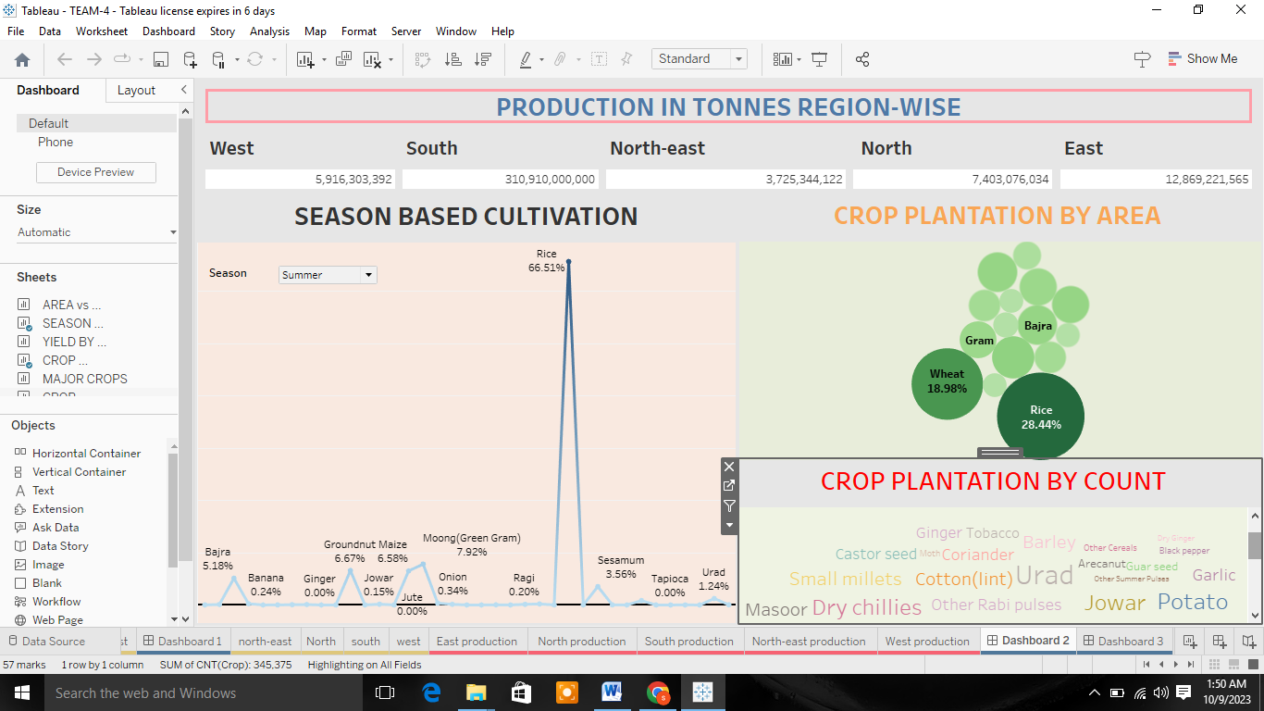

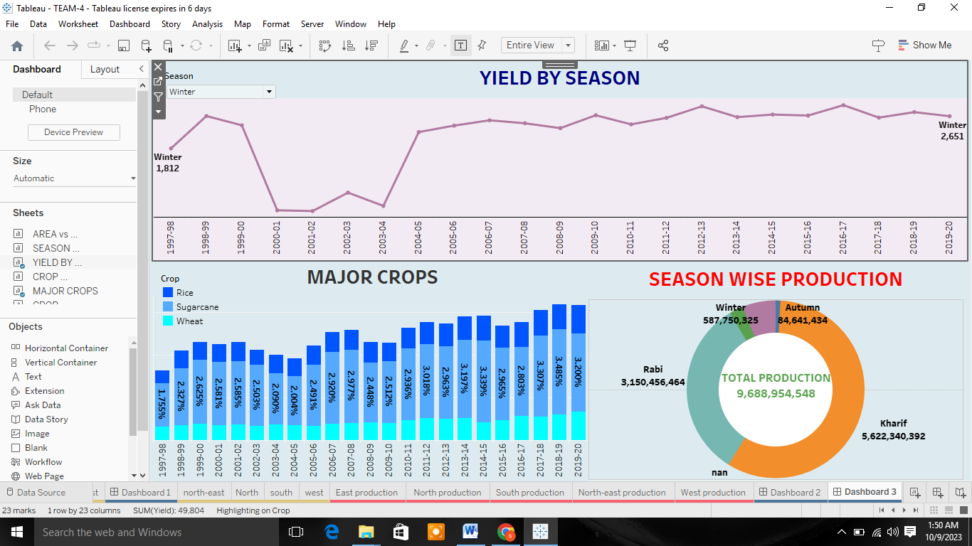

**4 (1) ADVANTAGES**

* Economic Benefits – Modern agriculture has had a positive impact on the economy, by creating jobs and generating revenue for farmers.
* Increased Food Production – Modern agriculture has enabled farmers to produce larger quantities of food, helping to address food shortage.
* Increased Efficiency – Modern farming methods are more efficient than traditional methods.

**4 (1) DISADVANTAGES**

* Soil Degradation – The intensive use of modern farming practices, such as heavy use of chemical fertilizers and pesticides.
* Water Pollution – The excessive use of chemical fertilizers and pesticides in modern agriculture can lead to runoff.
* Food Safety Concerns – The use of genetically modified crops and hormones in modern agriculture has raised concerns about the safety of the food supply.

**5 APPLICATIONS**

* Technology in agriculture affects many areas of agriculture, such as fertilizers, pesticides, seed technology, etc.
* Biotechnology and genetic engineering have resulted in pest resistance and increased crop yields. Mechanization has led to efficient tilling, harvesting, and a reduction in manual labor.
* The introduction of tractors was followed by new tillage and harvesting equipment, irrigation methods, and air seeding technology, all leading to improved quality of the food and fiber.

**6 CONCLUSION**

This project explains India’s agricultural crop production of India.

And my project gives Information about it…

**7 FUTURE SCOPE**

* The recent bout of drought in East Africa has propelled the demand for food grains.
* In fact, with growing climatic challenges, we require Agriculture scientists who can develop pest resistant varieties that give a bumper harvest.
* The Indian Government earned a lot of revenue by exporting wheat flour as counties of Africa & Mid East cannot get it from Ukraine.